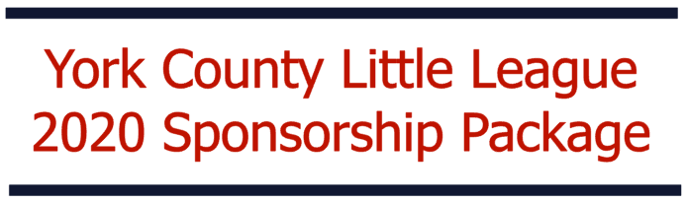
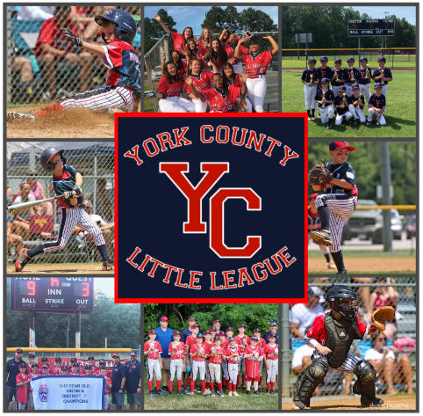


2020 YORK COUNTY LITTLE LEAGUE
SPONSORSHIP PROGRAM
Each year York County Little League (YCLL) faces the challenge of providing quality Little League Baseball and Softball to our players. While registration fees pay for a significant amount of the leagues recurring expenses, generous donations from community businesses, civic organizations and families help to improve our programs, equipment, and field conditions.
This year is no different than any other year when the league looks to our community for support to enhance the quality of programs we provide. Being a sponsor of York County Little League entitles you and/or your business to a host of advertising and marketing opportunities not available anywhere else. With over 1,000 active players involved in YCLL, the exposure and touch points we offer to both players and their families throughout the season is substantial. The media outlets we created allow us to keep our fans abreast of what’s going on in the league and ensure they are aware of specials made available by our sponsors. Being a league sponsor has its privileges.
To ensure the continued success of our sponsorship program, we have now simplified it to five different levels of sponsorship. We invite you to select one of the five options and make an impact on the youth of York County while broadcasting your positive image throughout the playing fields and homes of the 1,000 boys and girls actively participating in York County Little League.
The information you need to help you make the best decision for you and your company is provided in this package. Sign up and make a choice today to help YCLL for the 2020 season. York County Little League is a 501(c)(3) organization so your donations are tax deductible, and your quick response is greatly appreciated.
Thank you for your support,
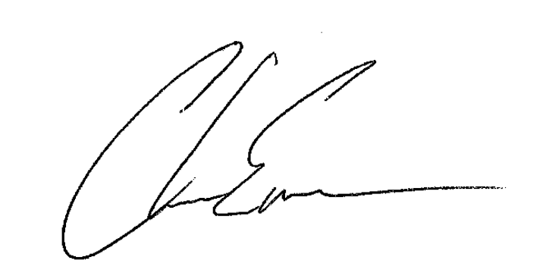
Chase Emerson
President, YCLL

Dear Future Sponsor:
Thank you for your consideration in sponsoring one of America’s greatest sports through the York County Little League (YCLL). We are proud to announce that YCLL is now a part of the York County Chamber of Commerce! Our league offers excitement and growth in baseball and softball to over 1,000 boys and girls yearly and relies heavily on volunteers to form the foundations necessary to run our league. The money you donate as a sponsor helps us to maintain playable field conditions, replace or repair equipment, and better our programs which carries on throughout the year, not just during our sports seasons.
When our regular Spring Season is over, your donations continue to help in allowing our teams who win District 7 Titles to have a chance at the State Title. Your donation doesn’t just help provide a season of Little League; it helps children learn our great pastime and provides enhanced playing opportunities for more advanced players.
Each year our teams have the opportunity to play for the District 7 title and represent District 7 in state tournaments. Our league is able to provide some financial assistance to our title winners, however, the teams must also rely on their own fundraising, as state competitions can be expensive with lodging costs, transportation, food, etc.
When you decide to sponsor with YCLL, several benefits are available to you depending on the level of sponsorship you choose:
- Level 1: Single Sponsorship ($150 and under)
  - Your company will receive a “shout out” on our Facebook Page
  - A YCLL window decal

- Level 2: Double Sponsorship ($300.00)
  - Your company name on 1/4th of a banner
  - Company recognition on the YCLL website
  - A YCLL window decal
  - A YCLL hat

- Level 3: Triple Sponsorship ($500)
  - Your company name on 1/2 of a banner
  - Company recognition on the YCLL website
  - Booth Space on Opening Day
  - A YCLL hat and YCLL shirt
  - A YCLL window decal

- Level 4: Home Run Sponsorship ($750)
  - Your company name on a full color 3x5 banner
  - Company recognition on the YCLL website
  - Booth Space on Opening Day
  - Sponsorship plaque with Team photo
  - YCLL hat and YCLL shirt
  - A YCLL window decal

- Level 5: Grand Slam Sponsorship ($1,000)
  - Your company name on a full color 3x5 banner
  - Company recognition on the YCLL website
  - Corporate advertising on our Facebook Page (we have over 1,500 followers) 2 Corporate specific posts: 1 Spring and 1 Fall
  - Booth Space on Opening Day
  - Opening Day Ceremonial First Pitch for one member of your company
  - Sponsorship plaque with Team Photo
  - YCLL Team Hat and YCLL Shirt
  - A YCLL window decal

As you can see, we offer a variety of sponsorship levels and believe our sponsors should be recognized at every level, no amount is ever too little to help our community and our youth. We thank you for your consideration in sponsoring YCLL.
On behalf of the 2020 YCLL Players, Volunteers & Board of Directors,
WE THANK YOU!
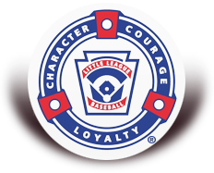

YCLL SPONSORSHIP AGREEMENT

Company or Organization: ______________________________________________

Address: ______________________________________________
______________________________________________
______________________________________________
Contact Number: ______________________________________________
Email Address: ______________________________________________
Contact Name (Please Print): ___________________________________________
Shirt Size: _______________________________________________
Signature of Authorized Representative: ___________________________________
Date: ___________________________________

YCLL Tax ID # 54-6053124
If you have any questions, please contact Allison Yost at sponsor@ycll.net.

Make checks payable to: YCLL
PO Box 1730
Yorktown, VA 23692

Disclaimer: The Board of Directors of YCLL has the right to refuse sponsorship
Banner and Website Information
YCLL will need your information to complete the York County Little League Website Advertising and Banner.
To complete the banner, please have the following information prepared and sent in: YCLL needs your banner image in either vector format (ex. PDF) or bitmap format (ex. JPEG, GIF, BMP) in the highest resolution possible and sized proportionally. The image you provide to YCLL will be printed directly, as is, to the banner itself. Please be careful to specify the content of the wording that you which to have displayed on the banner.

If you selected the Grand slam, please send us the promotional information you would like for us to post on our Facebook page, worded exactly the way you want it. We will post the exact verbiage that is sent to us to our followers.

If your sponsorship package includes the opening day booth, you will need to provide the table to display your company information. YCLL does not own tables to be able to assist with this part of the day. More information on Opening Day booths will be provided as we draw closer to Opening Day Spring 2020.

If you have any questions, please reach out to Allison Yost at sponsor@ycll.net.

